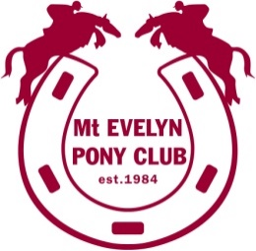

**Mount Evelyn Pony Club Inc.**

**MENU**

**Egg & Bacon Roll $5.00**

**Chicken Roll $7.00**

**Hot Dog $4.00**

**Dim Sims $1.25**

**Toasted Sandwich (Cheese) $3.00**

**Toasted Sandwich (Cheese/tomato) $3.50**

**2 Minute Noodles $3.00**

**Sausage in Bread (Veg available) $3.00**

**Chocolates $2.50**

**Chocolates small (Frogs/Koalas) $1.50**

**Potato Chips $2.00**

**All Drinks (Soft drink, Water, Juice) $2.50**

**Hot Drinks (Tea, Coffee, Hot Choc $1.00**

**Icy Poles (Summer Only) $2.00**

**Special Of the Day $5.00**

**(Soup & Roll, Fried Rice, Nachos etc.)**

***Prices as at 31/5/2023 Subject to change***